4 Creating the Shape

# Our Starting Point

We are going to continue our curve from where we left off in the last tutorial. So, right now, you should have a curve that looks something like this.

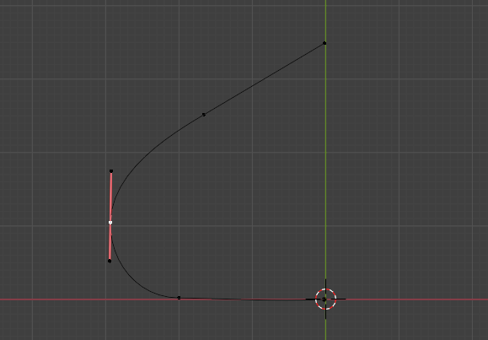

We are next going to change the location of the first section of the curve that we have on the left. It is the part that is lying on the floor. So, select it middle point.

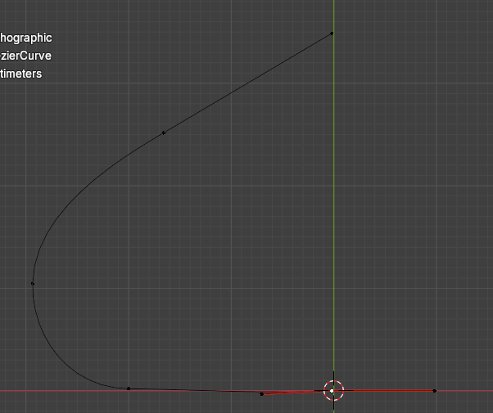

We want to move that point so its handle control point is lying slightly to the left of where the cursor is on the floor.

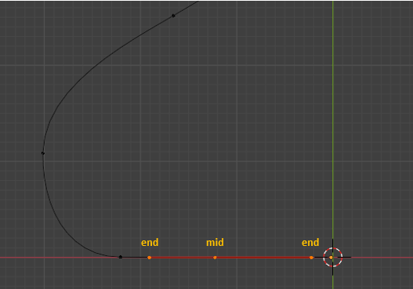

Now click on that mid- point, and hit the E key to extrude it. We can hold down the Y key at the same time to constrain it to the Y axis so this point moves straight downward.

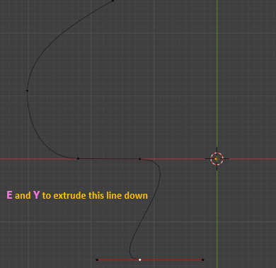

Change these two controls to have Automatic Handles. Hit the V key to change the handle type.

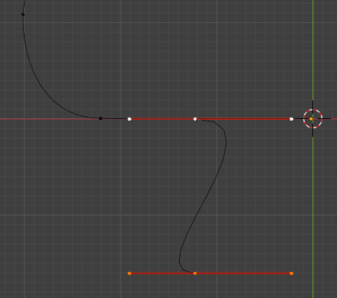

Now select the end point on the right handle and change that handle type to Vector. It will now point straight downward. The left handle, you can move to flatten out on the floor.

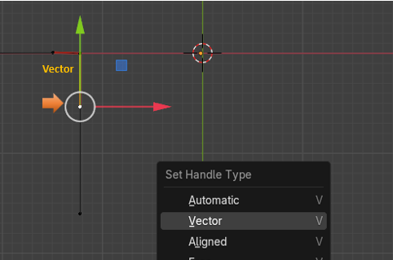

# Move Cursor to Selected

We are going to be moving the cursor a couple of times to get it located to where we actually want it. To do this, we will first need to select this mid-point here on this control.

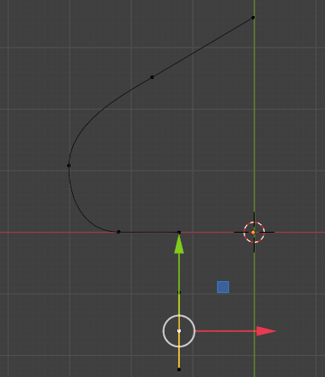

Now with that mid-point selected we can hit Shift and S, then at the bottom of the menu that pops up, we want to select Cursor to Selected.

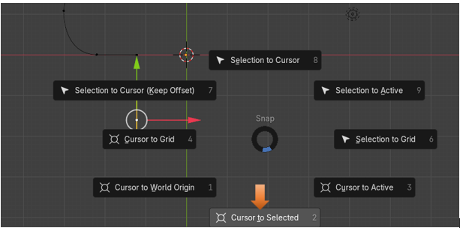

Note-To come out of the menu overlay, just press Shift and S again.

But we actually do not want the 3D Cursor sitting on that control point, we actually want it to sit on the green line that runs straight up and down at the center of our project in the view port.

So, to do that we need to open up that panel at the right side of the viewport using the N key. Go to the View tab, to reach the settings for the 3D Cursor. We need to change the X for Location of the 3D Cursor to get it to sit where we want. Now notice that the red and white ring is sitting on the green line where we want it.

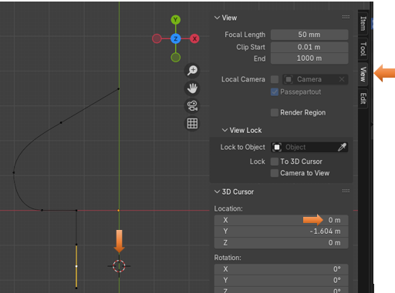

# Add a Bezier Circle

Now anything that we add to the scene will be added where the 3D cursor is located. And this is where we want to add it.

Notice that we are doing this in the Edit workspace, and not the Object workspace.

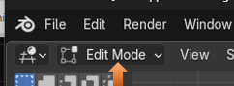

Hit Shift -A to add a circle

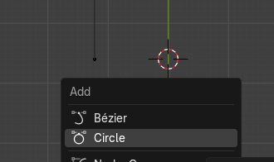

See the circle was added around that 3D cursor, location we just specified.

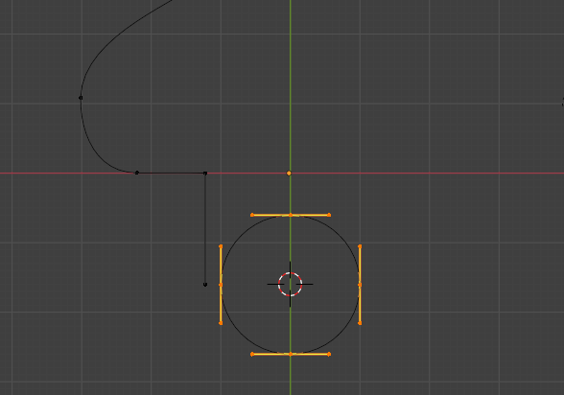

<https://www.youtube.com/watch?v=f53GvpTIO2w>

